**Instrumentation and Measurement**

**Assignment**

**Name:** K.V.N.G.Vikram

**SC code:**  SC15B148

**Roll no:** 8

**Step input response of a second order system**

**Code:**

clear  
clc

t = 0:0.01:20;  
u = 1*double(t>=1);  
s = tf('s');  
w = [1 0.5 2 10 50] ;  
z = [0 0.3 0.6 1 1.5 3];  
figure(1)  
hold()  
plot(t,u,'--','Linewidth',2)  
for i = 1:numel(z)  
 G = (w(1)^2)/(s^2 + w(1)^2 + 2*z(i)*w(1)*s);  
 y = lsim(G,u,t);  
 plot(t,y,'Linewidth',2)  
end  
  
legend('Input signal','Zeta = 0','Zeta = 0.3','Zeta = 0.6','Zeta = 1','Zeta = 1.5','Zeta = 3')  
title('Step response for Wn = 1')  
xlabel('Time')  
ylabel('Amplitude')

figure(2)  
hold()  
plot(t,u,'--','Linewidth',2)  
z1 = 0.3;  
for i = 1 : numel(w)  
 G = (w(i)^2)/(s^2 + w(i)^2 + 2*z1*w(i)*s);  
 y = lsim(G,u,t);  
 plot(t,y,'Linewidth',2)  
end  
legend('Input signal','Wn = 1','Wn = 0.5','Wn = 2','Wn = 10','Wn = 50')  
title('Step response for different Wn for underdamped system Zeta = 0.3')  
xlabel('Time')  
ylabel('Amplitude')

figure(3)  
hold()  
plot(t,u,'--','Linewidth',2)  
z1 = 1;  
for i = 1 : numel(w)  
 G = (w(i)^2)/(s^2 + w(i)^2 + 2*z1*w(i)*s);  
 y = lsim(G,u,t);  
 plot(t,y,'Linewidth',2)  
end  
legend('Input signal','Wn = 1','Wn = 0.5','Wn = 2','Wn = 10','Wn = 50')  
title('Step response for different Wn for critically damped system Zeta = 1')  
xlabel('Time')  
ylabel('Amplitude')

figure(4)  
hold()  
plot(t,u,'--','Linewidth',2)  
z1 = 4;  
for i = 1 : numel(w)  
 G = (w(i)^2)/(s^2 + w(i)^2 + 2*z1*w(i)*s);  
 y = lsim(G,u,t);  
 plot(t,y,'Linewidth',2)  
end  
legend('Input signal','Wn = 1','Wn = 0.5','Wn = 2','Wn = 10','Wn = 50')  
title('Step response for different Wn for overdamped system Zeta = 4')  
xlabel('Time')  
ylabel('Amplitude')

clear  
clc

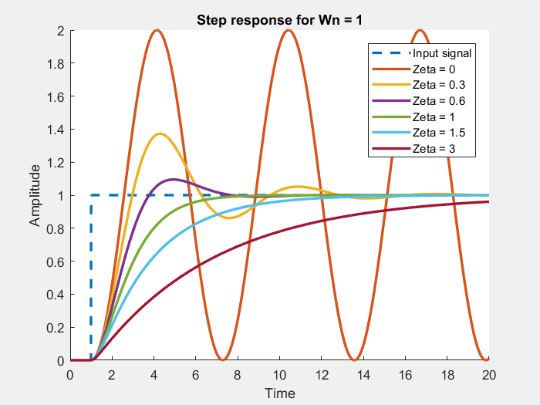

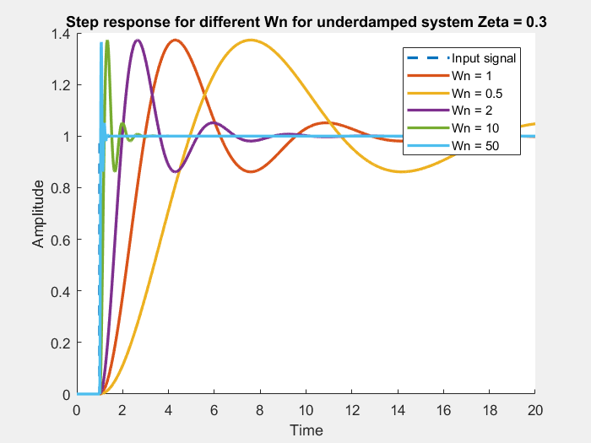

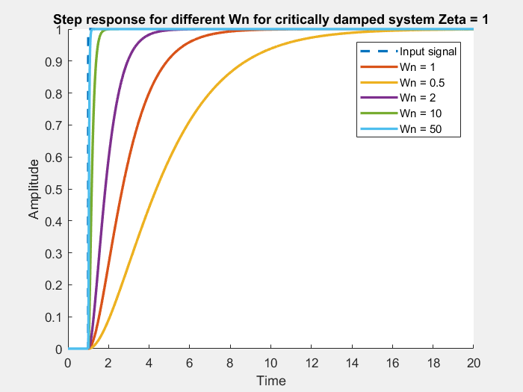

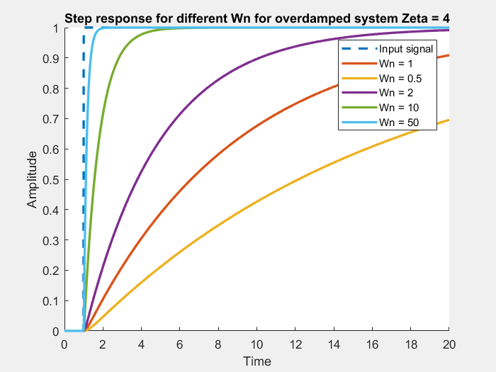

**Variation of overshoot with Zeta in step response**

**Code:**

clear  
clc

z = 0:0.01:1-0.01;  
mp = exp(-z.*pi./((1-z.^2).^0.5));  
plot(z,mp*100,'r','Linewidth',2)  
title('Variation of % overshoot with Zeta')  
xlabel('Zeta')  
ylabel('%')  
%title()

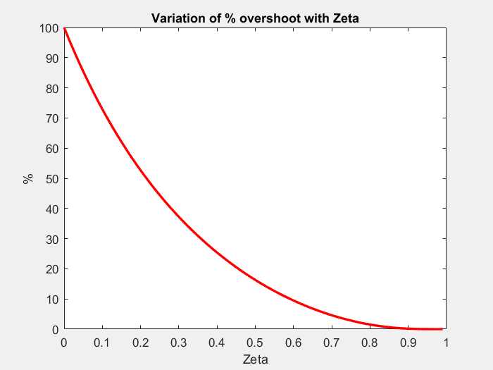

[*Published with MATLAB® R2017a*](http://www.mathworks.com/products/matlab)

**Frequency and Phase responses of second order system**

**Code:**

clear  
clc

w = 0:0.01:20;  
w = 1j*w;  
z = [3 1.5 1 0.8 0.6 0.4 0.2];

Wn = 1;  
figure()  
hold()  
for i = 1:numel(z)  
 H = (Wn^2)./(w.*w + Wn^2 + w.*2*z(i)*Wn);  
 plot(real(w/1j),abs(H),'Linewidth',2)  
  
end  
xlabel('Frequency')  
ylabel('Gain')  
legend('Zeta = 3','Zeta = 1.5','Zeta = 1','Zeta = 0.8','Zeta = 0.6','Zeta = 0.4','Zeta = 0.2')  
title('Frequency response for Wn = 1')  
figure()  
hold()  
for i = 1:numel(z)  
 H = (Wn^2)./(w.*w + Wn^2 + w.*2*z(i)*Wn);  
 plot(real(w/1j),phase(H)*180/pi,'Linewidth',2)  
  
end  
xlabel('Frequency')  
ylabel('Phase')  
legend('Zeta = 3','Zeta = 1.5','Zeta = 1','Zeta = 0.8','Zeta = 0.6','Zeta = 0.4','Zeta = 0.2')  
title('Phase response for Wn = 1')

Wn = 5;  
figure()  
hold()  
for i = 1:numel(z)  
 H = (Wn^2)./(w.*w + Wn^2 + w.*2*z(i)*Wn);  
 plot(real(w/1j),abs(H),'Linewidth',2)  
  
end  
xlabel('Frequency')  
ylabel('Gain')  
legend('Zeta = 3','Zeta = 1.5','Zeta = 1','Zeta = 0.8','Zeta = 0.6','Zeta = 0.4','Zeta = 0.2')  
title('Frequency response for Wn = 5')  
figure()  
hold()  
for i = 1:numel(z)  
 H = (Wn^2)./(w.*w + Wn^2 + w.*2*z(i)*Wn);  
 plot(real(w/1j),phase(H)*180/pi,'Linewidth',2)  
end  
xlabel('Frequency')  
ylabel('Phase')  
legend('Zeta = 3','Zeta = 1.5','Zeta = 1','Zeta = 0.8','Zeta = 0.6','Zeta = 0.4','Zeta = 0.2')  
title('Phase response for Wn = 5')

Wn = 10;  
figure()  
hold()  
for i = 1:numel(z)  
 H = (Wn^2)./(w.*w + Wn^2 + w.*2*z(i)*Wn);  
 plot(real(w/1j),abs(H),'Linewidth',2)  
  
end  
xlabel('Frequency')  
ylabel('Gain')  
legend('Zeta = 3','Zeta = 1.5','Zeta = 1','Zeta = 0.8','Zeta = 0.6','Zeta = 0.4','Zeta = 0.2')  
title('Frequency response for Wn = 10')  
figure()  
hold()  
for i = 1:numel(z)  
 H = (Wn^2)./(w.*w + Wn^2 + w.*2*z(i)*Wn);  
 plot(real(w/1j),phase(H)*180/pi,'Linewidth',2)  
  
end  
xlabel('Frequency')  
ylabel('Phase')  
legend('Zeta = 3','Zeta = 1.5','Zeta = 1','Zeta = 0.8','Zeta = 0.6','Zeta = 0.4','Zeta = 0.2')  
title('Phase response for Wn = 10')

clear  
clc

